XML Configuration File

What is an XML Configuration File?
# Source: AI Source: Provided by: [Data Path: Persons Table -> ID Column: 1, Name_En Column: Motasem Essam] -> From: [Chatgpt (GPT‑5 Mini)] on [1/26/2026]
An XML Configuration File is a text-based file format using XML (eXtensible Markup Language) to store structured configuration data for an application.
- XML is hierarchical, meaning it uses nested tags to define relationships between settings.
- Widely used in legacy enterprise apps, Java applications, .NET apps, and Android apps.
- Can be validated using XML schemas (XSD) to ensure correctness.

Key Characteristics
# Source: AI Source: Provided by: [Data Path: Persons Table -> ID Column: 1, Name_En Column: Motasem Essam] -> From: [Chatgpt (GPT‑5 Mini)] on [1/26/2026]
- Format:
  - Uses <tags> to define elements
  - Supports nested elements for structured data
  - Attributes can store additional info (<db host="localhost"/>)
  - Comments start with <!-- comment -->
- File Extension: .xml
- Purpose:
  - Store application settings, environment variables, API keys, feature toggles
  - Maintain hierarchical structure for complex configurations
  - Often used in enterprise systems or when strict validation is required

Example XML Configuration File
# Source: AI Source: Provided by: [Data Path: Persons Table -> ID Column: 1, Name_En Column: Motasem Essam] -> From: [Chatgpt (GPT‑5 Mini)] on [1/26/2026]
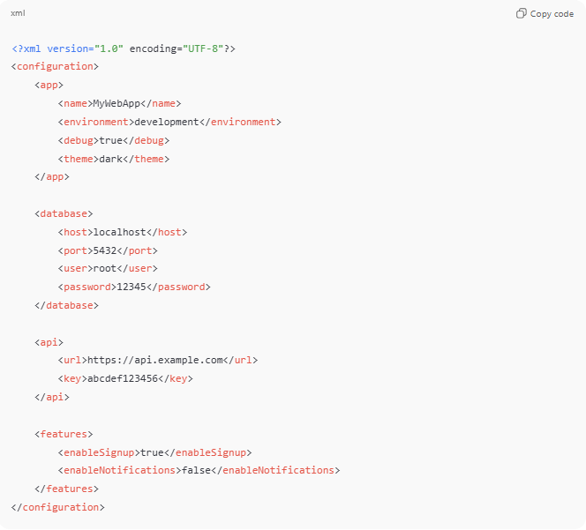
config.xml
<?xml version="1.0" encoding="UTF-8"?>
<configuration>
<app>
<name>MyWebApp</name>
<environment>development</environment>
<debug>true</debug>
<theme>dark</theme>
</app>

<database>
<host>localhost</host>
<port>5432</port>
<user>root</user>
<password>12345</password>
</database>

<api>
<url>https://api.example.com</url>
<key>abcdef123456</key>
</api>

<features>
<enableSignup>true</enableSignup>
<enableNotifications>false</enableNotifications>
</features>
</configuration>
- <app>, <database>, <api>, <features> → Nested elements representing sections
- <name>, <host>, <key> → Values inside each section

How to Use in Code
# Source: AI Source: Provided by: [Data Path: Persons Table -> ID Column: 1, Name_En Column: Motasem Essam] -> From: [Chatgpt (GPT‑5 Mini)] on [1/26/2026]
Python Example
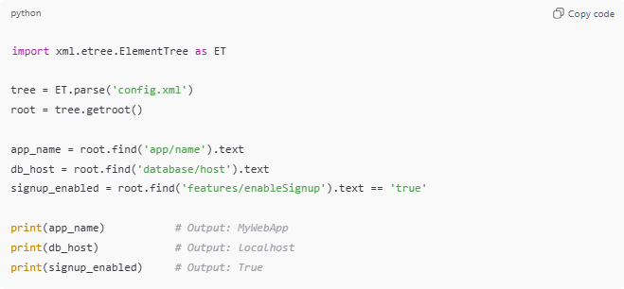
import xml.etree.ElementTree as ET

tree = ET.parse('config.xml')
root = tree.getroot()

app_name = root.find('app/name').text
db_host = root.find('database/host').text
signup_enabled = root.find('features/enableSignup').text == 'true'

print(app_name) # Output: MyWebApp
print(db_host) # Output: localhost
print(signup_enabled) # Output: True

Java Example
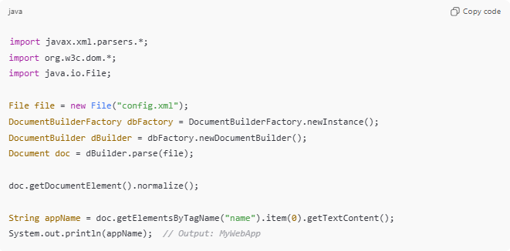
import javax.xml.parsers.*;
import org.w3c.dom.*;
import java.io.File;

File file = new File("config.xml");
DocumentBuilderFactory dbFactory = DocumentBuilderFactory.newInstance();
DocumentBuilder dBuilder = dbFactory.newDocumentBuilder();
Document doc = dBuilder.parse(file);

doc.getDocumentElement().normalize();

String appName = doc.getElementsByTagName("name").item(0).getTextContent();
System.out.println(appName); // Output: MyWebApp

Advantages of XML Configuration Files
# Source: AI Source: Provided by: [Data Path: Persons Table -> ID Column: 1, Name_En Column: Motasem Essam] -> From: [Chatgpt (GPT‑5 Mini)] on [1/26/2026]
- ✅ Hierarchical and structured (good for complex configs)
- ✅ Can validate with XML Schema (XSD)
- ✅ Widely supported in many languages and frameworks

Disadvantages
# Source: AI Source: Provided by: [Data Path: Persons Table -> ID Column: 1, Name_En Column: Motasem Essam] -> From: [Chatgpt (GPT‑5 Mini)] on [1/26/2026]
- ❌ Verbose (more typing than JSON/YAML)
- ❌ Less human-friendly than YAML
- ❌ Slower to parse than JSON

💡 Analogy:
# Source: AI Source: Provided by: [Data Path: Persons Table -> ID Column: 1, Name_En Column: Motasem Essam] -> From: [Chatgpt (GPT‑5 Mini)] on [1/26/2026]
XML config files are like a detailed, labeled tree diagram: every branch (section) has leaves (settings), and everything is strictly structured. Great for precision, but a bit heavy to read by humans.

